**DATATYPES AND FORMAT SPECIFIERS**

1. WAP to read the following information at run time and to display. Choose appropriate data type and format specifier.

1. username [maximum of length 125]

2. age

3. Salary [float]

4. Designation code [as short type with values {1, 2, 3, 4, 5, 6}

5. Gender [a single char field]

A:

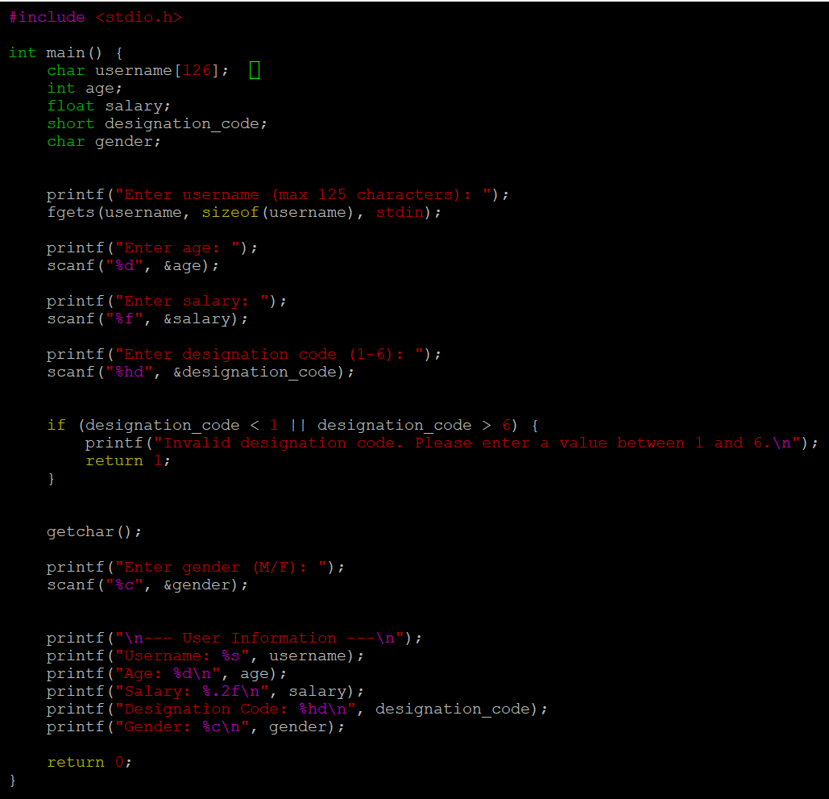

2. WAP to read a user choice as ‘y’ or ‘Y’ or ‘n’ or ‘N’ and display read choice as “Yes” or “No”

according to the input received.

‘y’ or ‘Y’à display “Yes”

‘n’ or ‘N’à display “No”

for any other character received à display “invalid character” and exit

A:

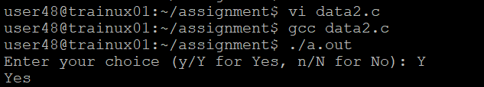

3. WAP to read a number in decimal (0-127) and display it in 2 digit hex characer.

A:

